Step 1. Go to ncu.edu.jm
Step 2. Click on Colleges & Schools. A drop down menu will appear, select Natural and Applied Sciences.
Step 3. After selecting ‘Natural & Applied Sciences’, another dropdown menu will appear, Select “Mathematics & Engineering”.
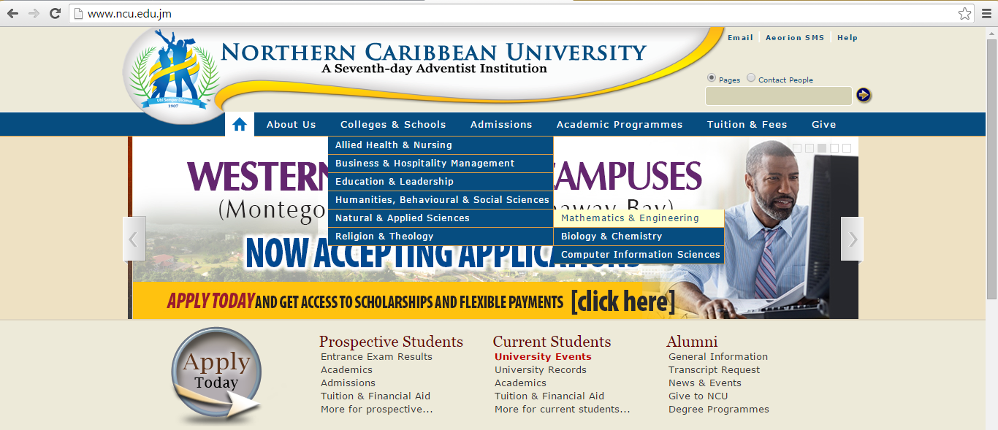

Step 5. Click on Placement Rest and Select Sample Test.
Step 6. The following window will appear. Read the instruction, click continue and you’ll be on your way to viewing the Math questions.

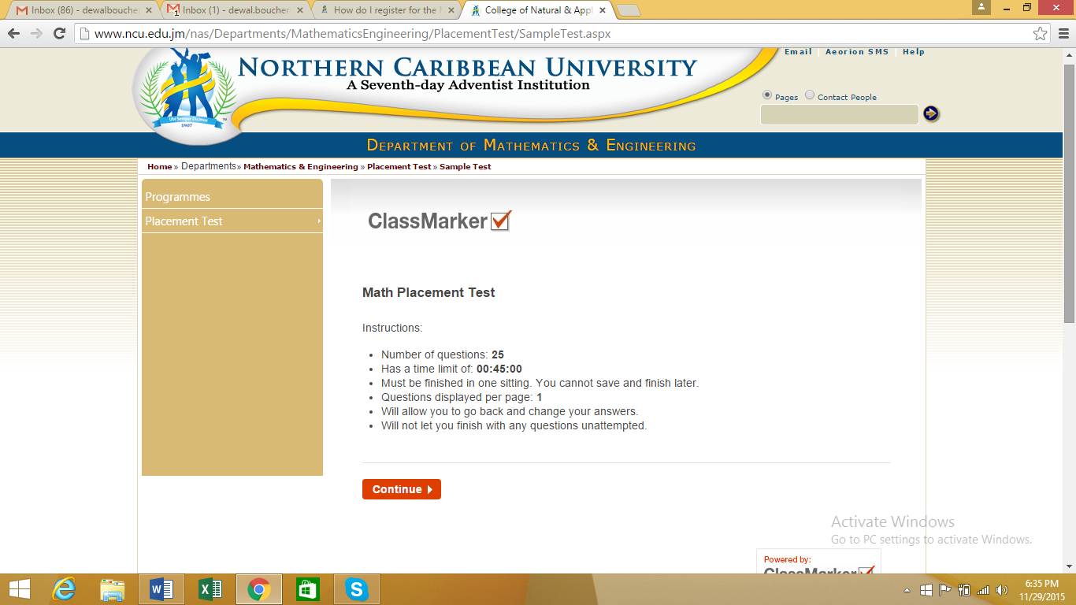

If you’re having challenges with this process, email techsupport@ncu.edu.jm or contact the Mathematics & Engineering Department at 963-7392.

